St. Joseph’s Anglo-Chinese School
Form 5 English Language
Paper 4 Speaking – Exam Practice (DSE 2016 Set 8.2)
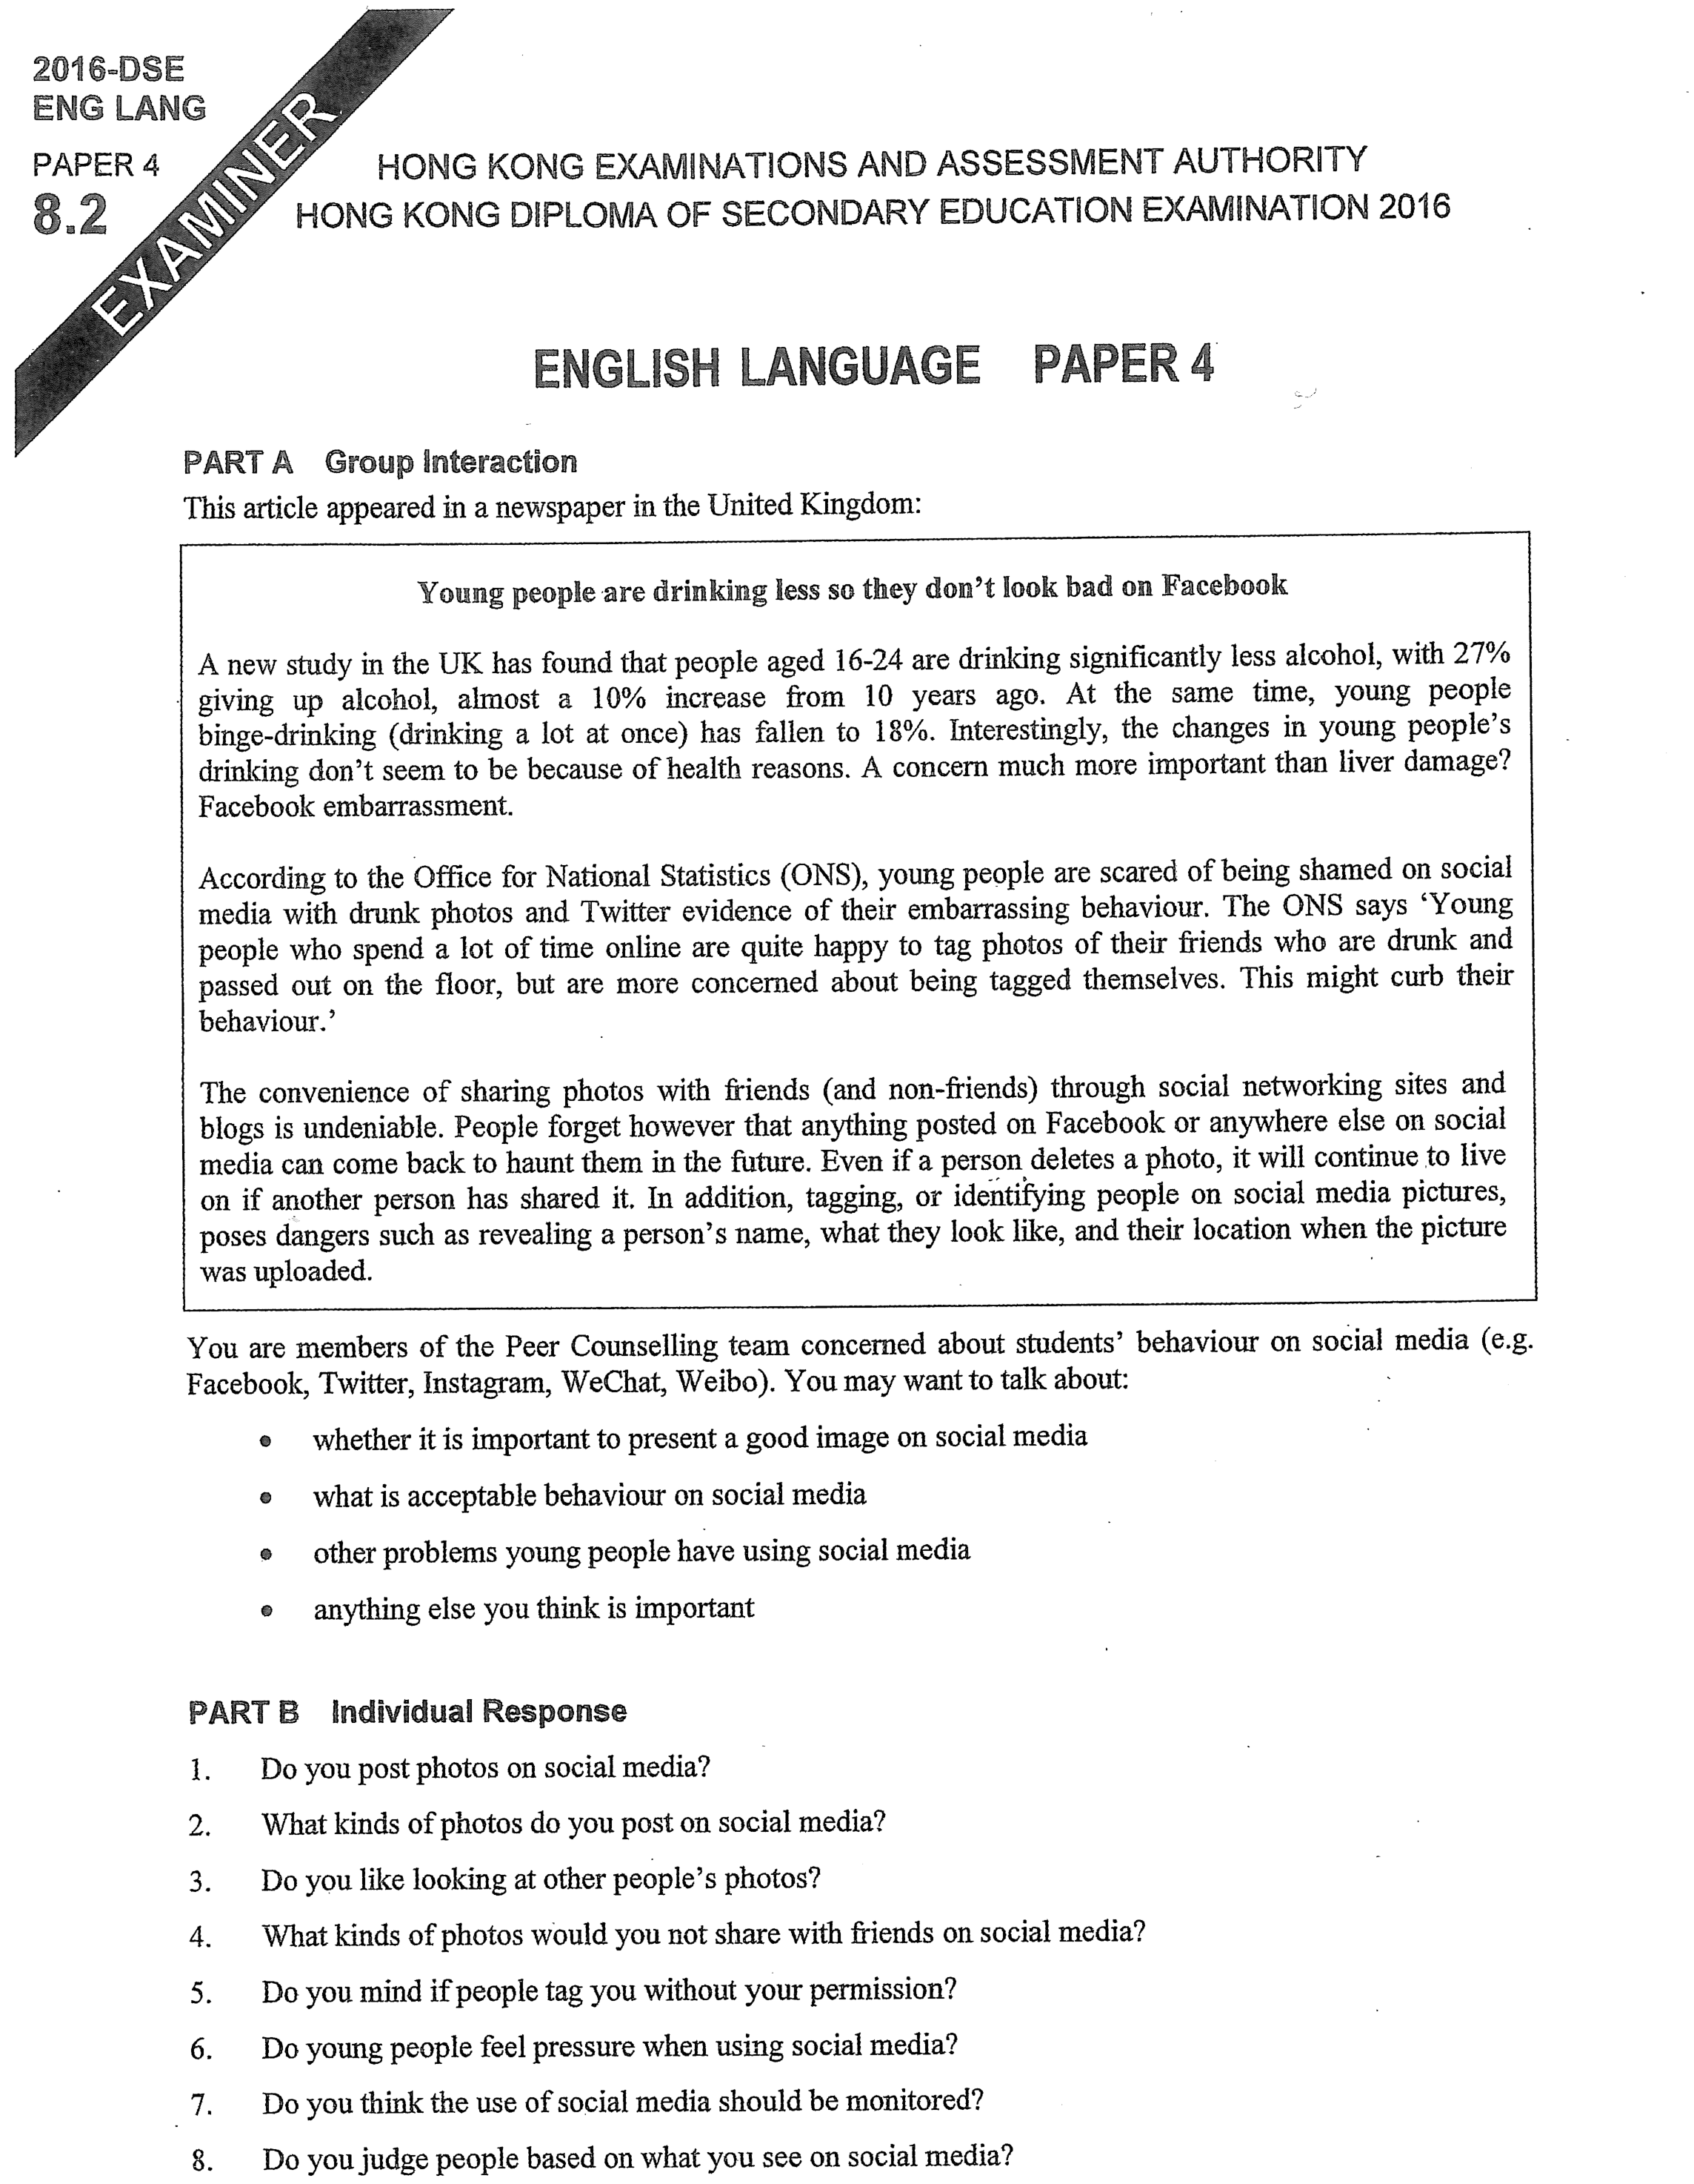

Note Grid – Your Notes for the Discussion
1. whether it is important to present a good image on social media | 2. what is acceptable behaviour on social media
3. other problems young people have using social media | 4. anything else you think is important

Note Grid – Your Notes for Part B Individual Response Questions
Question: ___________ | Question: ___________

