St. Joseph’s Anglo-Chinese School
Form 5 English Language
Paper 4 Speaking – Exam Practice (DSE 2018 Set 6.2)
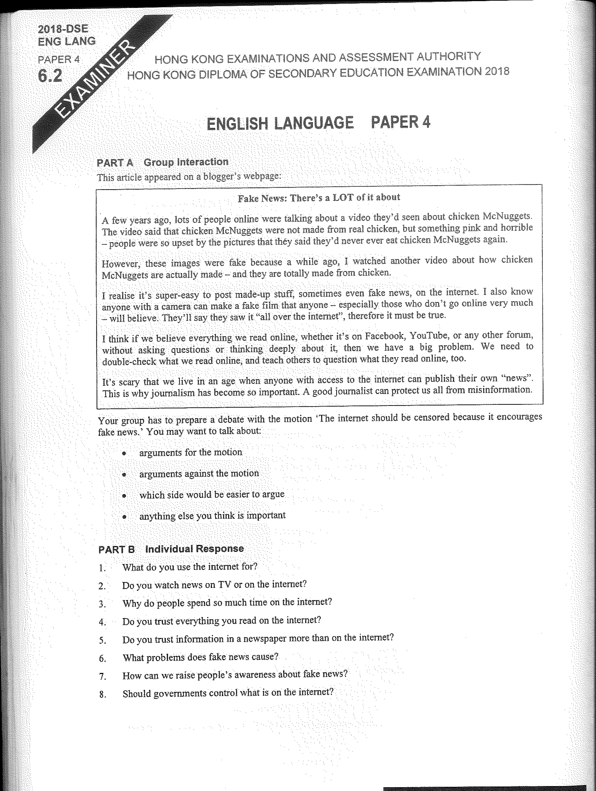

Note Grid – Your Notes for the Discussion
1. arguments for the motion | 2. arguments against the motion
3. which side would be easier to argue | 4. anything else you think is important

Note Grid – Your Notes for Part B Individual Response Questions
Question: ___________ | Question: ___________

