St. Joseph’s Anglo-Chinese School
Form 5 English Language
Paper 4 Speaking – Exam Practice (DSE 2018 Set 1.2)
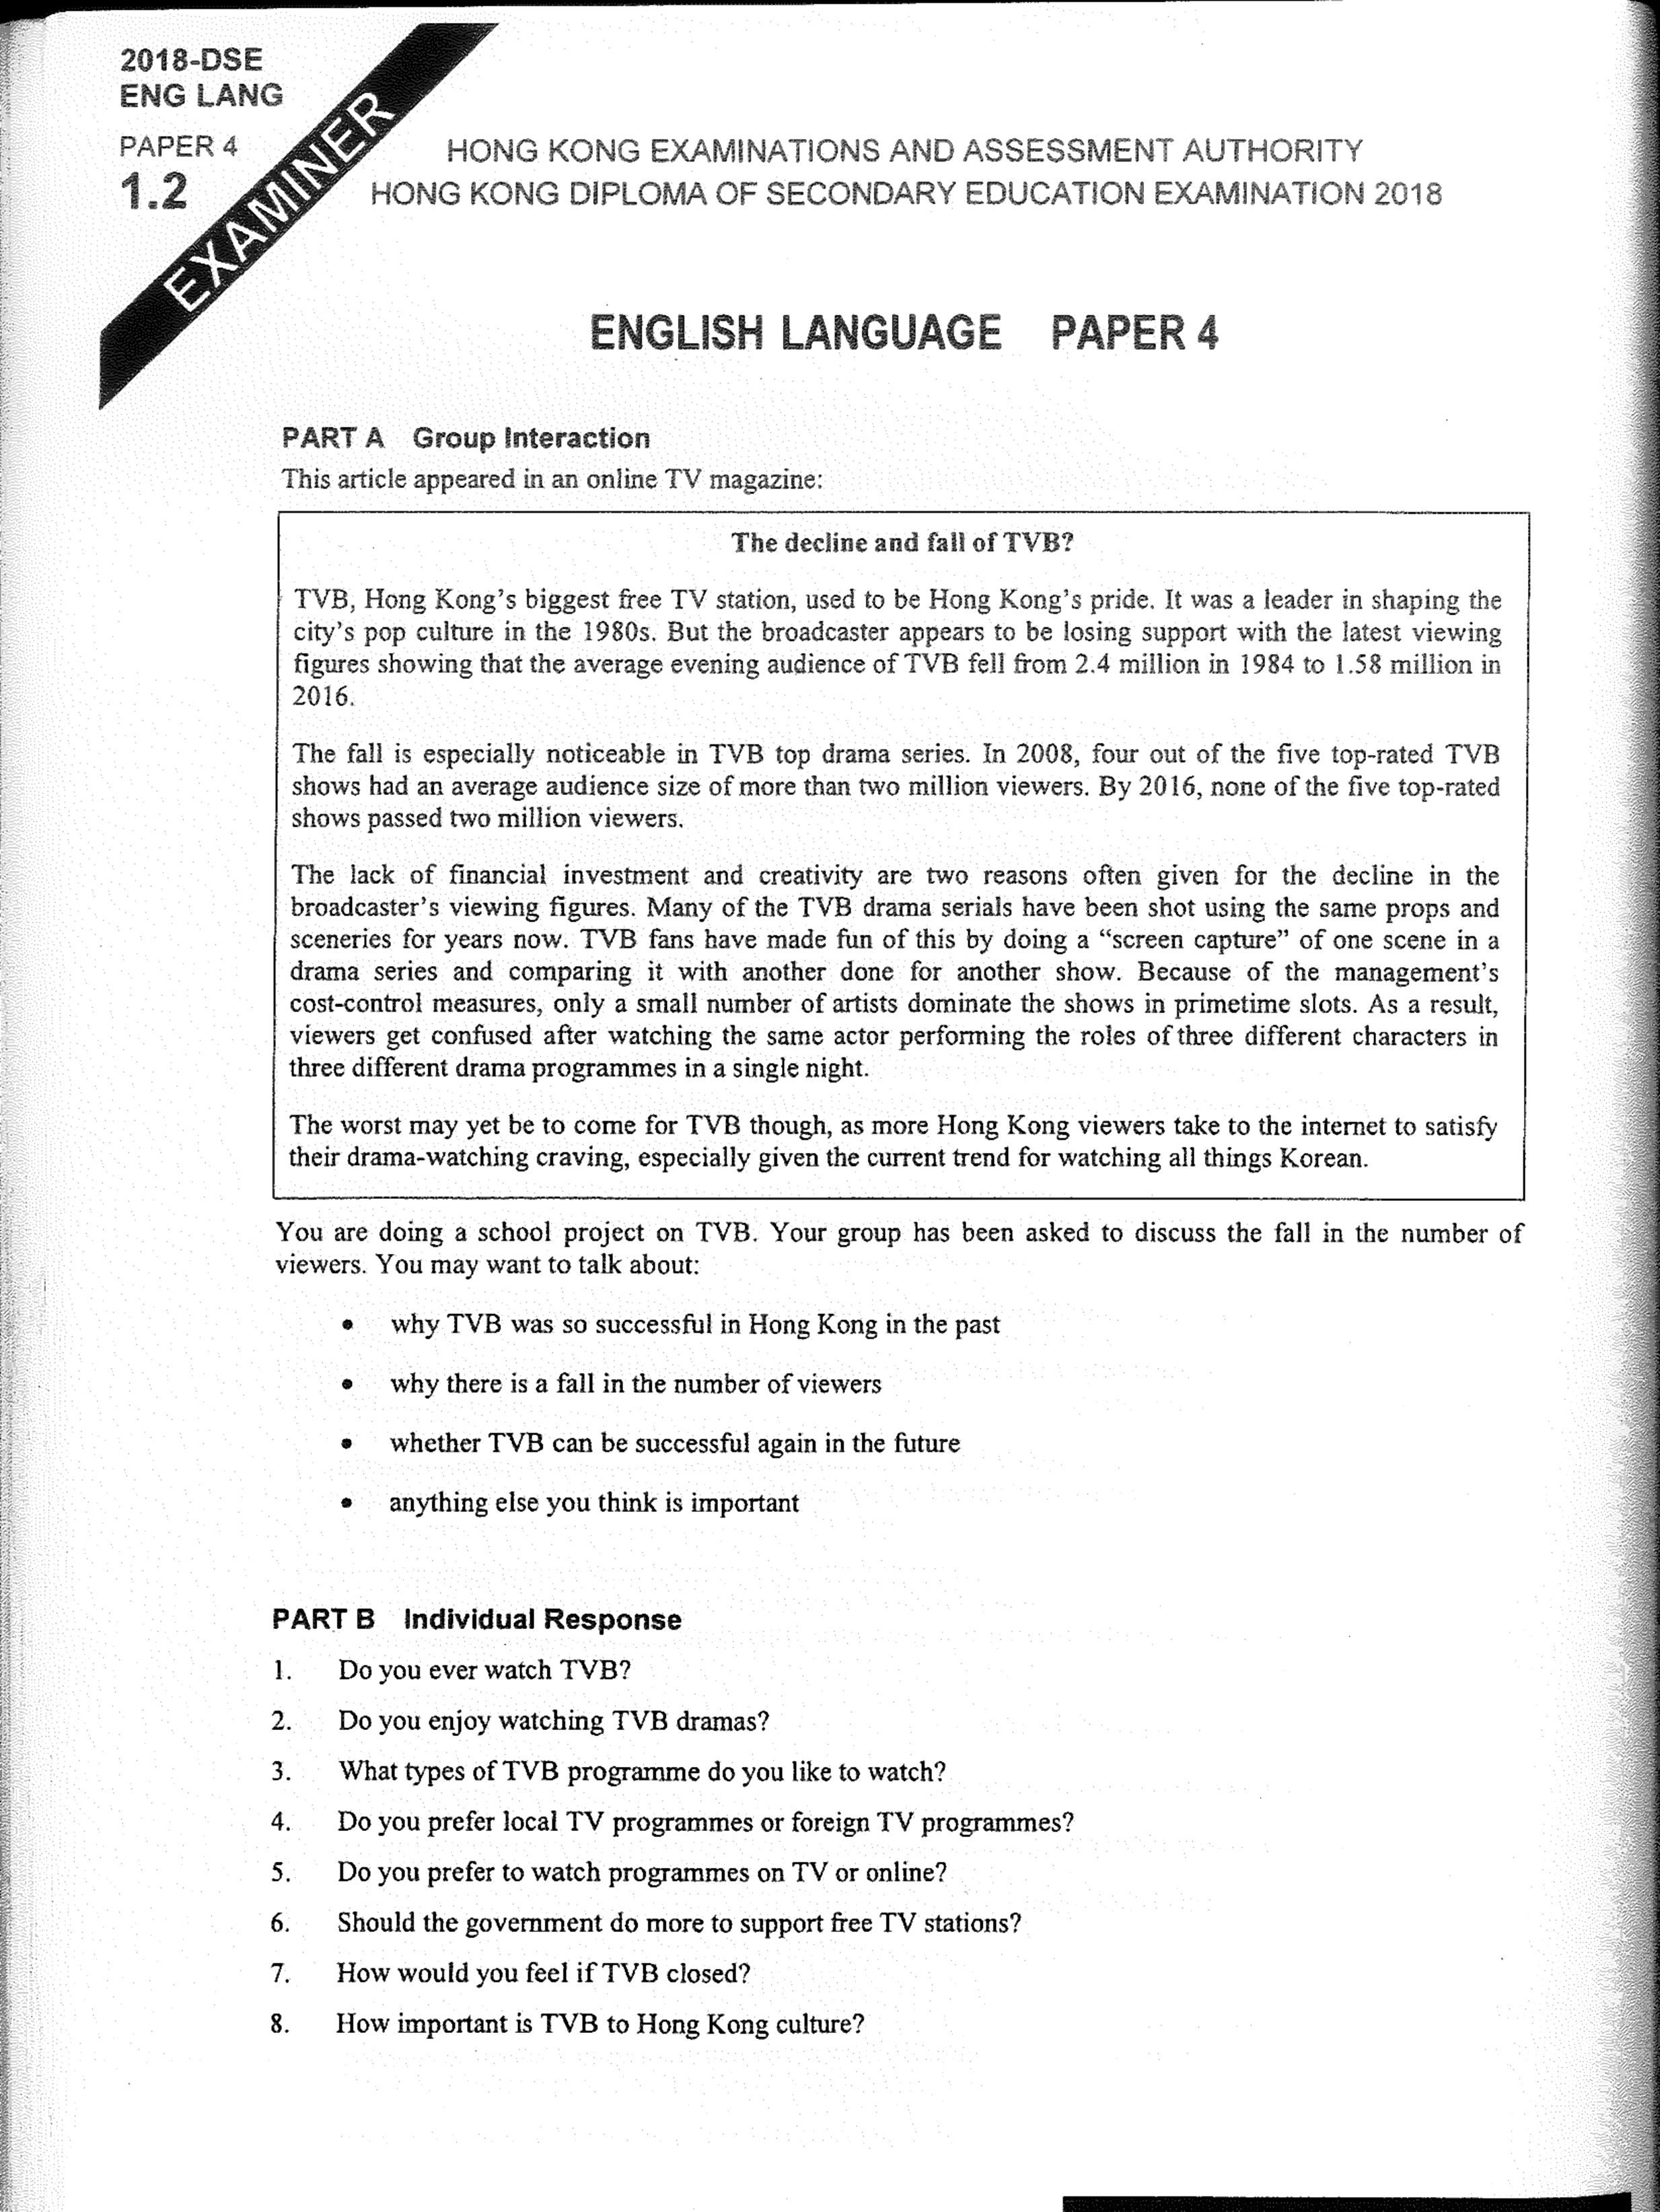

Note Grid – Your Notes for the Discussion
1. why TVB was so successful in Hong Kong in the past | 2. why there is a fall in the number of viewers
3. whether TVB can be successful again in the future | 4. anything else you think is important

Note Grid – Your Notes for Part B Individual Response Questions
Question: ___________ | Question: ___________

