St. Joseph’s Anglo-Chinese School
Form 5 English Language
Paper 4 Speaking – Exam Practice (DSE 2016 Set 1.1)
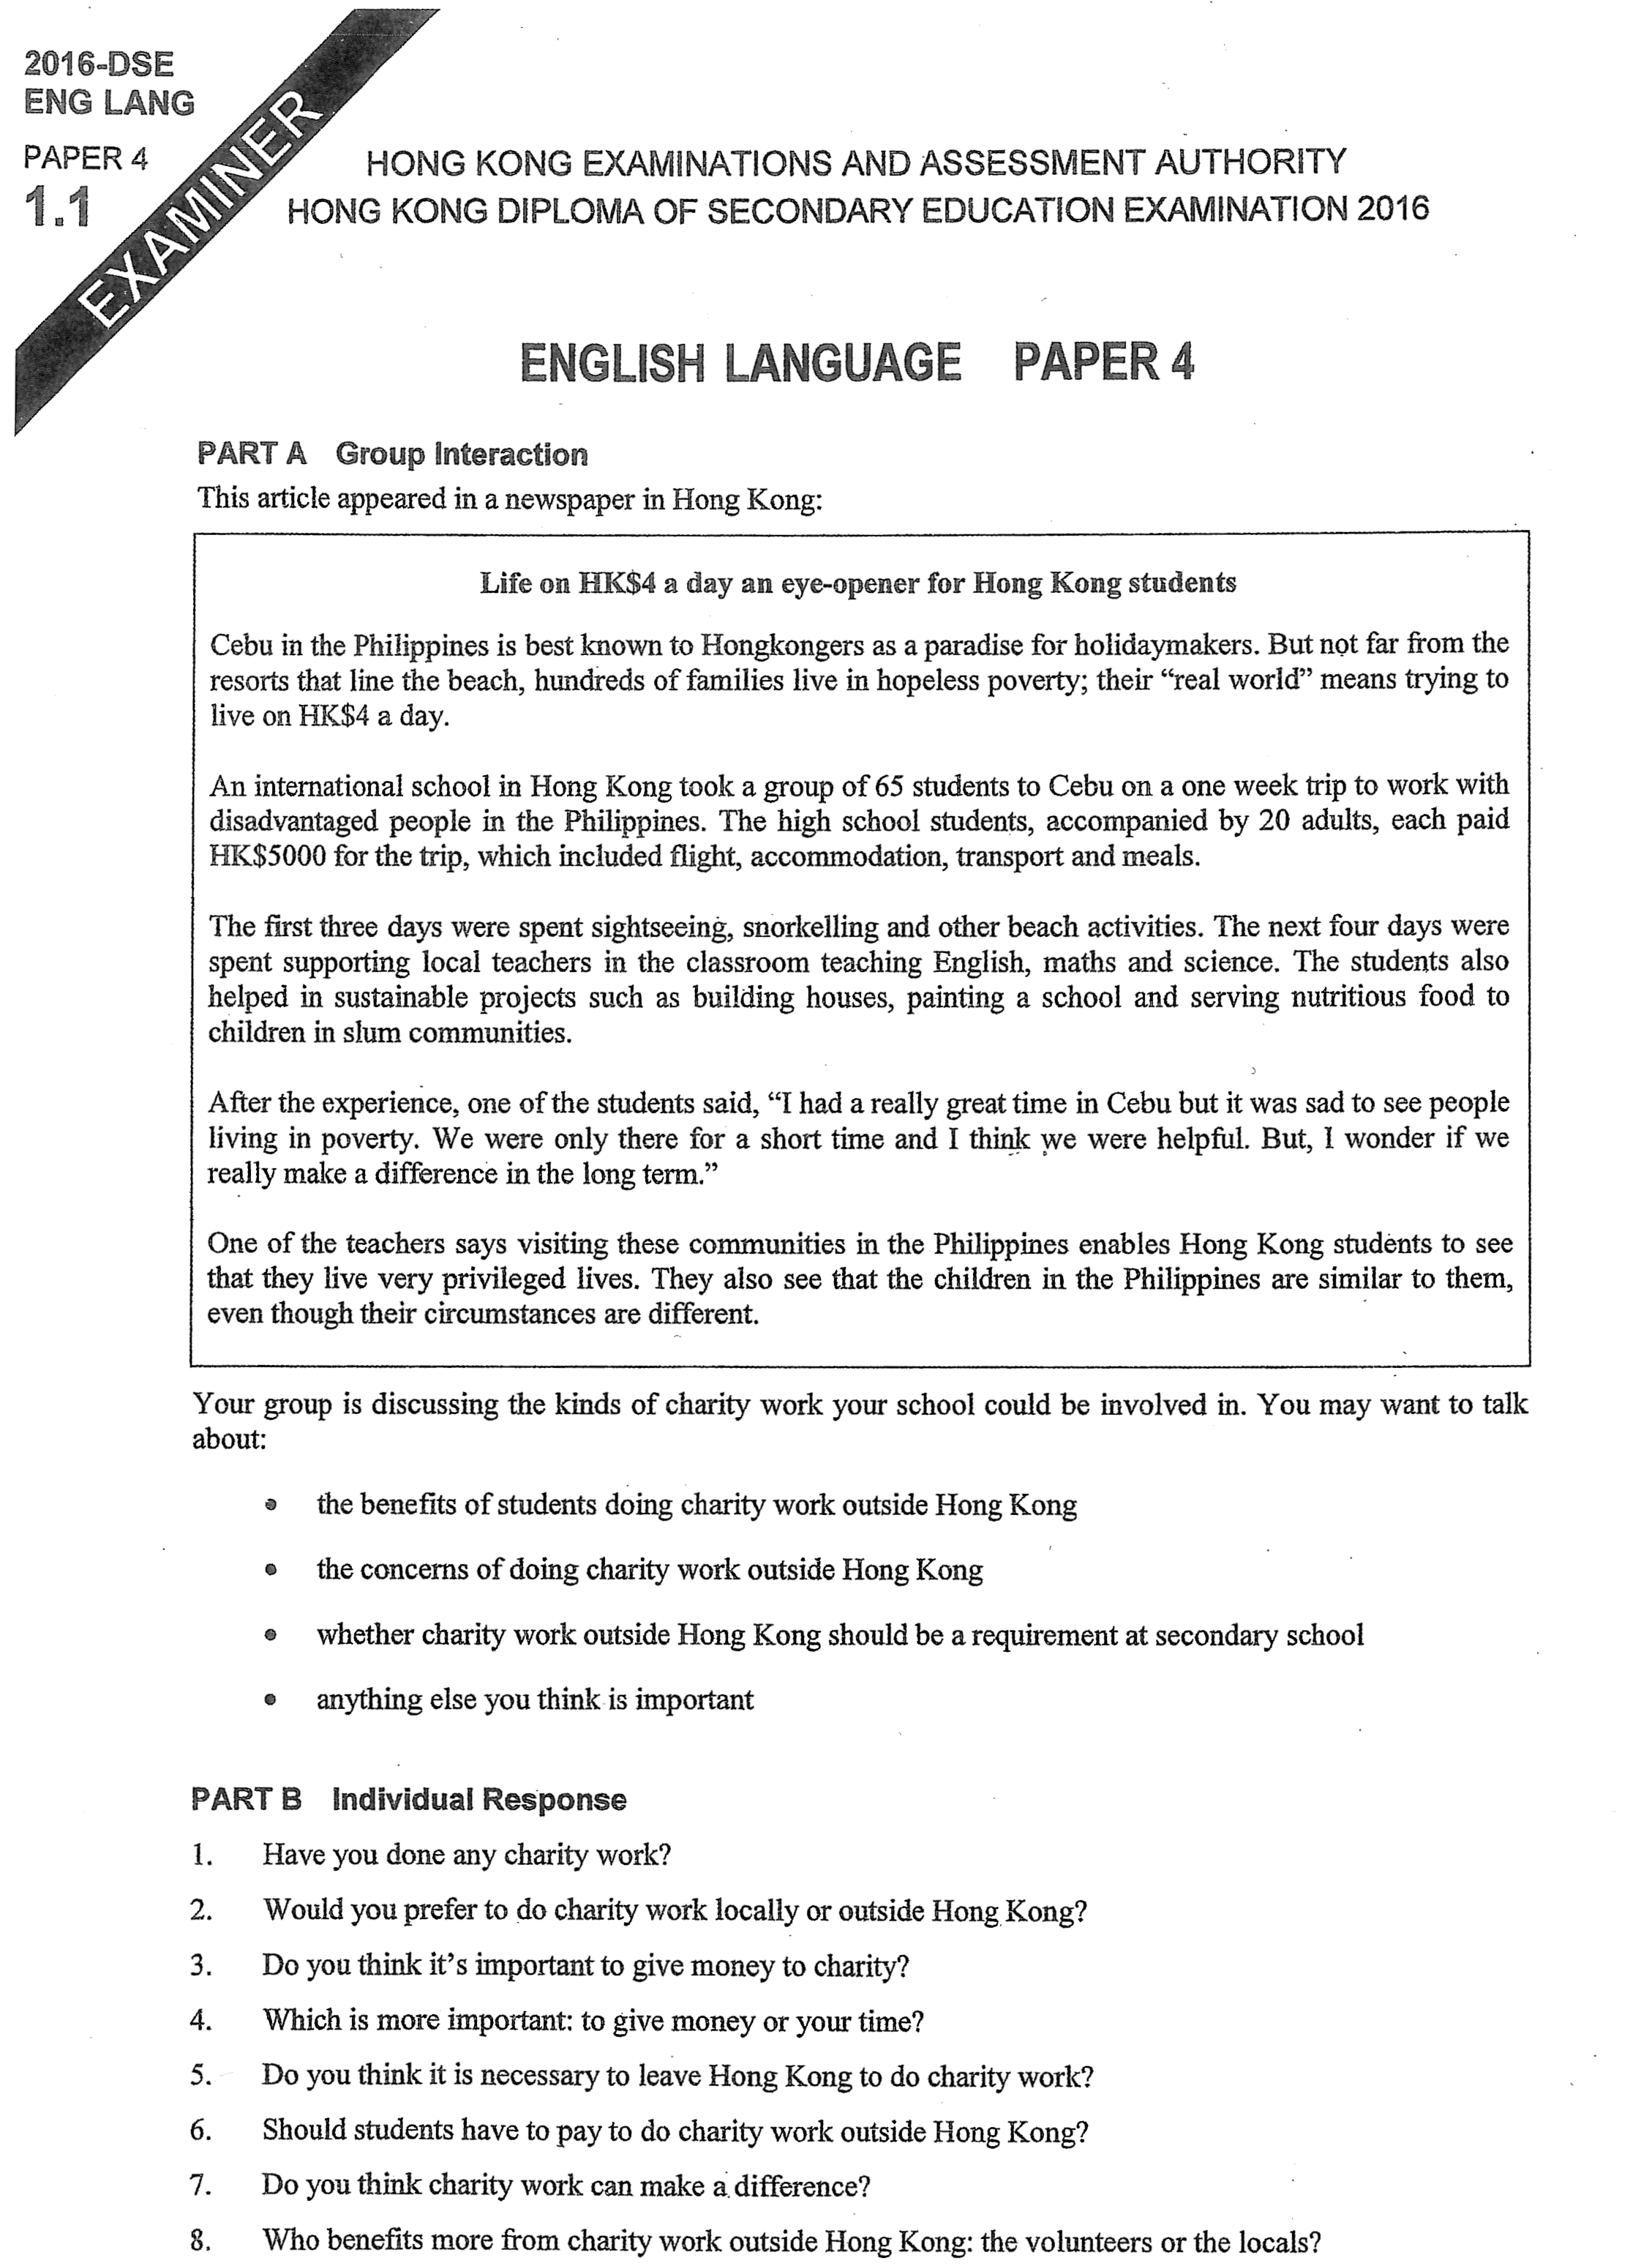

Note Grid – Your Notes for the Discussion
1. the benefits of students doing charity work outside Hong Kong | 2. the concerns of doing charity work outside Hong Kong
3. whether charity work outside Hong Kong should be a requirement at secondary school | 4. anything else you think is important

Note Grid – Your Notes for Part B Individual Response Questions
Question: ___________ | Question: ___________

