St. Joseph’s Anglo-Chinese School
Form 5 English Language
Paper 4 Speaking – Exam Practice (DSE 2016 Set 6.3)
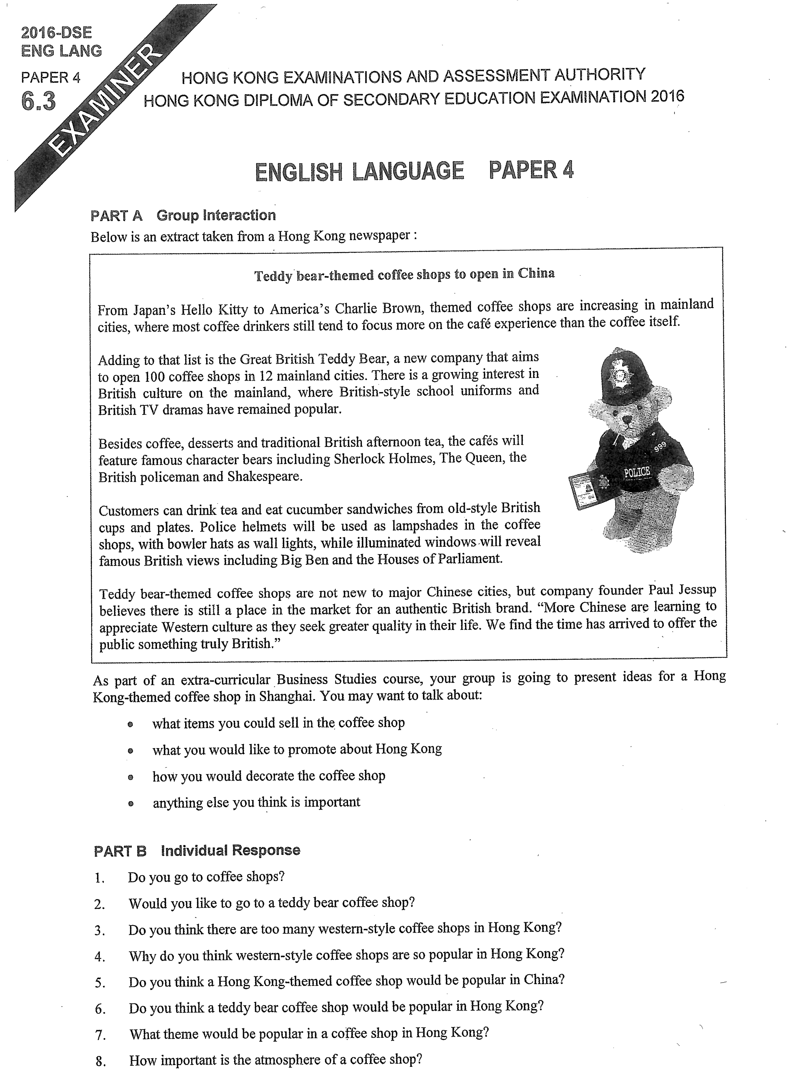

Note Grid – Your Notes for the Discussion
1. what items you could sell in the coffee shop | 2. what you would like to promote about Hong Kong
3. how you would decorate the coffee shop | 4. anything else you think is important

Note Grid – Your Notes for Part B Individual Response Questions
Question: ___________ | Question: ___________

